*SUMMER TRAINING REPORT ON*

**“ANALYSIS OF FINANCIAL STATEMENTS”**

Undertaken at

**“Jay Ace Technologies”**

*Submitted in partial fulfillment of the requirements*

*For the award of the degree of*

**B.Com (H) 2018-2021**

*Under the Guidance of*  *Submitted by*

**Ms. Shabman Ansari Khushi Bisht**

Faculty Guide 002244388818



**Sirifort Institute of Management Studies**

**Affiliated to Guru Gobind Singh Indraprastha University, Delhi**

Plot no 8, Institutional Area, Sector 25, Rohini, New Delhi, Delhi -110085

##### STUDENT DECLARATION

##### To Whom It May Concern

I KHUSHI BISHT, Enrolment No. 002244388818 from BCOM(H) -V Sem of SIRIFORT INSTITUTE OF MANAGEMENT STUDIES , Delhi hereby declare that the Summer Training Report entitled ANALYSIS OF FINANCIAL STATEMENTS at JAY ACE TECHNOLOGIES is an original work and the same has not been submitted to any other Institute for the award of any other degree.

**Name of student:**Khushi Bisht

**Enrollment no:** 002244388818

**Program:**Bcom (H)

**Batch:**2018-21

**Date:**07/01/21

**COUNTERSIGNED BY:**

**Name of faculty guide :** Ms Shabnam Ansari

**Date::**07/01/21

**Project completion certificate**

**This is to certify that Khushi Bisht, a student of B.Com(H) , a class of 2018, Sirifort Institute of Management Studies, Affiliated to GGS.IP. University bearing Enrolment No 002244388818 , has undertaken the Summer Internship Training at Jay Ace Technologies under my supervision & guidance.**

**He / She has conducted a study & completed the STR Titled “ANALYSIS OF FINANCIAL STATEMENTS”**

**Shabnam Ansari**

**Assistant Professor**

**Internship Certificate**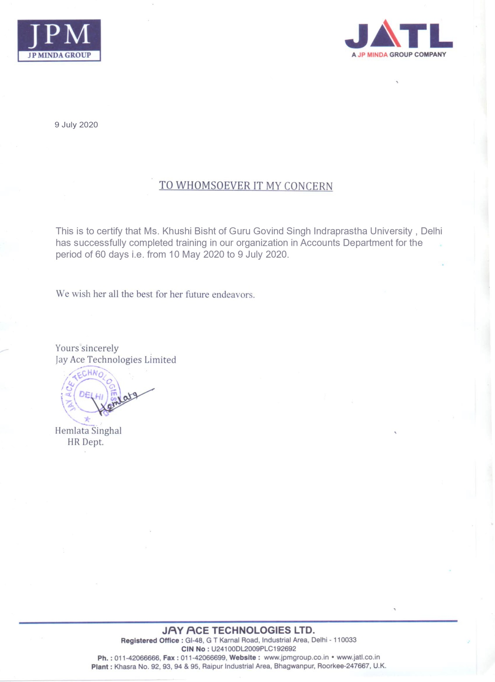

**ACKNOWLEDGEMENT**

As the outset I am grateful to **Jay Ace Technologies**  for having given me the opportunity to do my summer internship with them.

I take this opportunity to thank **Mr. Rajendra Singh** who not only served as my guide at **Jay Ace Technologies**, but also encouraged and challenged me throughout my summer internship program. He gave me his valuable time and guided me at each step with his experience and provided me all the required information.

A sense of gratitude is nor enough to express my sincere thanks towards**Mr. Yogesh Tiwari** who guided me with his insights and knowledge. He took active interest in my project and was always there to give me his word of guidance.

My sincere thanks to **Ms Shabman Ansari**, my faculty guide who took active interest in my project and was always there to give her word of valuable guidance.

I duly acknowledge with gratitude the help and cooperation received from the entire Jay Ace Technologies team.

**Khushi Bisht**

**TABLE OF CONTENTS**

|  |  |  |
| --- | --- | --- |
| **S.No.** | **Topic** | **Page No.** |
| 1 | Student Declaration | 2-3 |
| 2 | Internship Certificate | 4 |
| 3 | Acknowledgement | 5 |
| 4 | Chapter I: Introduction  Objective of the study  Research Methodology  Limitation of the study | 7-8  9-10  11  12 |
| 5 | Chapter II: Profile of the company | 13-40 |
| 6 | Chapter III: Analysis and Interpretation of Data | 41-57 |
| 7 | Major documents | 58-63 |
| 8 | Chapter IV: Conclusion and Recommendation | 64-66 |
| 9 | My Experience | 67 |
| 10 | Bibliography | 68 |
|  |  |  |
|  |  |  |
|  |  |  |
|  |  |  |
|  |  |  |
|  |  |  |

**Chapter I**

**Introduction**

The project is on **“ANALYSIS OF FINANCIAL STATEMENTS”**

The main objective of the study was to study financial statements of **JAY ACE TECHNOLOGIES.** The project includes the mission and objectives of the company along with its performance and the product line. The report includes the functions of the finance department, its structure and working.

The report will first give you a brief about Accounting system at **JAY ACE Technologies**, Financial statements of JAT Limited.,

You will also get information on Import procedure followed at JAT, Export procedure followed at **JAT**; the report includes each and every step involved in the import/export of any product, as well as the major documents required.

After this you will come to know about use of electronic data in decision making at **JAT.**

Apart from this you will come to know about how I analyzed & interpreted the collected data. I hope that you will find this report interesting & will help you in conducting further studies on this sector.

**Corporate Mission**

Established in 2006, Jay Ace Technologies is a significant arm of JPM Industries that manufacture various types of high quality automotive batteries, standardized as per industry benchmark.

Co

**Corporate Objectives**

* To be a leading battery manufacturer in India operating in the competitive global environment, with focus on bulk as core competency and to improve returns on capital employed.
* To render high quality of service to all categories of customers with professionalism and efficiency.
* To provide support services to the medium and small scale sectors.
* To streamline system within the Company for settlement of commercial disputes.

**OBJECTIVE OF THE STUDY**

**To study the ‘working and functions’ at the finance department of JAT**

The specific objectives of the report are to know in details about the operation ofJAT. The project has been directed by the following objectives:

* To study the nature and scope of regulatory environment of the company.
* To know how most of the targets are achieved in the company.
* To know how various tasks like, data entry, tender floating, trading, fund management, etc. are performed in the company.
* Exploring that how JAT. Control their total financial activities.
* To know about the various kinds of product and service provided by JAT.
* Finally to identify the findings regarding the investment activities or other relevant things those are essential for the Companies and give some recommendations to overcome the problems those are found.

Moreover, my career-objective is to enter into the corporate world. Keeping in line with my goal, I wanted to adore myself with professional skills. Thus, I took this opportunity to acquaint myself with the ‘Working and Functions’ of the finance department.

**Paras Jain**

**Research Methodology**

**Research Approach**: The project has been basically a descriptive type of research.

**Data Collection Instruments**: The study has been primarily based upon information extracted from official documents. Interviews with the managers and officers of various departments were also being conducted. On the other hand, secondary sources (WEB Site) were used to collect data regarding the company and different kinds of papers, annual reports, etc are the major secondary sources.

**Scope of the Report**

The report covers the organizational structure, background, functions and the performance of the JAT**.** The scope of the study is just to acquaint with the operational scenario of JAT.

**Limitations of the Report**

There were some limitations of the study and therefore the report may lack some crucial data. Such as:

♦ The general activities of Finance department are so vast. So that’s why they were not being able to give me enough time.

♦ Time of my internship program was very short. So it was not possible to collect more information within this short time.

♦ They did not provide me vast information because of their official obligations.

♦ All the information is not included in this report due to confidentiality of organization.

The project has encountered these limitations that may have hinder progress. But with constant effort, my goal was to minimize the negative efforts of these limitations

**Chapter II**

**Profile of the Company**

Established in 2006, Jay Ace Technologies is a significant arm of JPM Industries that manufacture various types of high quality automotive batteries, standardized as per industry benchmark.

**About Jay Ace Technologies**

JAT is a significant arm of JP MINDA Industries that manufacture various types of high quality automotive batteries, standardized as per industry benchmark.

This 500-employee strong organization is focused on quality and customer satisfaction. In order to ensure consistent quality of products manufactured from here , it is necessary to have a benchmark to adhere to. As such they follow ISO/TS 16949 standards.

**FACILITIES**

Owing to the rich tradition of work ethics of its Parent entity (JPM Group), Jay Ace too has furthered it by installing some of the best facilities available across the nation today.   
Some of them are listed below:

* Grid Casting Machines
* Oxide Millers
* Pasting Machines with Acid Soaking
* Lead Oxide Storage and Handling Systems
* High Pressure Spine Casting
* Automatic Curing-cum-Drying Ovens
* Acid Recirculating Charging Systems
* Plate Parting Machines
* Online HRD Testing Machines
* **Assembly Lines:** They have dedicated assembly lines for every product that they manufacture.This ensures isolation and insulation of one process from another. This also helps in reducing machine errors, human errors and ensures proper coordination between the different stages of work.
* **Testing Facilities:** Since they are a technology and quality driven business conglomerate, it is imperative for us to deliver high quality product everytime to their clients.
* **Design Facilities:**They have designing facilities installed in our organization to ensure top notch quality products.

**Company features**

Jay Ace is an ISO/TS 16949:2009 certified business entity that caters to wide range of automotive batteries for its esteemed clientele. We have a state-of-the-art manufacturing plant in Roorkee with a strength of 500 employees to deliver quality driven products.

**Products**

Jay Ace makes some of the best quality-driven and cost-effective automotive solutions to India’s leading mobility service provider.

* **Automotive Batteries -**[Car Batteries, Batteries for LCVs, SUVs, MUVs](http://jpmgroup.co.in/Batteries.htm) and [HCVs](http://jpmgroup.co.in/Batteries.htm) including DIN and MF range of Batteries.
* **Inverter Batteries -** Flat Plate Batteries, Tubular Batteries,Tall Tubular Batteries.
* **SMF -**VRLA Batteries.
* **Two-Wheeler Batteries -**Dry Charged, VRLA (2.5,5,7,9 AH).

**Objectives of the JAT**

* To achieve and continue growth in sales
* To continuously develop human resources

Provide our Consumers with the Best Service & Shopping Experience in the Country. Provide our Consumers with Products of Latest Technology. Develop our Employees to achieve their real potential. Provide our Shareholders with steady Asset Growth and Return on investment above our Industry Norm. Grow our Revenue and Profits at a rate above the Industry Norm.

**Mission**

**Our mission is to improve the quality of life by providing comforts and conveniences at affordable prices.**

* The mission statement emphasizes on the company's inclination towards fulfilling the need of the people, by offering them a novel set of quality products at a reasonable cost. Over the years, JAT has come up with a variety of goods and Company like Jay Ushin Ltd, Jay Industries Ltd, Jay Iber Ltd, Jay Castings Ltd, JPM Tools Ltd , Jay Fe cylinders Ltd , JNS instruments Ltd , JPM Automotive Ltd , JNJ electronics Ltd , JTL waterway Ltdto meet the ever-changing needs of people. A vision becomes tangible as a mission statement.

This statement has some parts, those are listed below:

* Improve the life of people.
* Providing comfort and conveniences.
* Affordable price.

Last but not in the list,

* Providing service generation to generation.

These entire conditions make JAT ltd mission successful.

**Vision**

**To be the most admired and respected familiar company in the country.** Corona Group has been successful in realizing this vision by creating a lasting brand name in every Agri. Equipment all over the Country among the world. Corona Group has continued to expand in the field of consumer durables by acquiring new companies producing related products. It also describes aspiration for the future, without specifying the means necessary to achieve those desire ends. Corona Group has continued to expand in the field of consumer durable and also increasing social responsibility. It has created a lasting brand name in every Agri. hold all over the world.

**Value**

**To treat our employees, recognizing them as assets of the company to honor and maintain high ethical standards.**

**1. Consumers:** We live up to the expectations of a responsible Organization by contributing to the improvement in the Quality of life of our customers through outstanding product & services.

**2. Employees:** We respect each other as individual and encourage cross functional teamwork while providing Opportunities for career development.

**3. Dealers:** We provide a reasonable return to our Dealers while, safeguarding their investment.

**4. Suppliers:** We develop our suppliers to be partners in progress arid share our growth with them.

**5. Competitors:** We respect our competitors and recognize their contribution to mixed value.

**6. Community:** We conduct our business by conforming to the ethics of our country and share the social responsibility of the less fortunate.

**Management Strategy**

Corona Group consistently focuses on growth and risk minimization through product diversification and increasing the market share of existing products by responding to changing customer needs.

**Strategy:**

A Proper strategy is important to the success of a business. Strategy to sale the products are-

* **Push Strategy:** Push strategy requires pushing the dealers to sale the products on their own responsibility. Sales of our products largely depend on the dealers. Dealers convince the customers to buy our products. In this case dealers take the responsibility to publicize the product to sale. They also do it to achieve their own sales target given by CTL.
* **Pull Strategy:** Pull strategy requires creating a demand of the product in the mind of the customers by advertisements and other promotional activates.

**SWOT Analysis:**

This SWOT analysis is done to understand what the dealers present for CTL. That means what strength, weakness, opportunity, threat do the dealers possess in terms of CTL’ business.

**Strength:**

• Reaching the product to remote places: it is really convenient to reach consumers of remote areas of the country through dealers.

• Flexibility: as per the requirement or the situation of the business in certain areas CTL can easily withdraw their businesses,

• No fixed assets cost: Dealer are not CTL fix assets. Therefore cost can be minimized of establishing fixed assets like CTL own retail outlet.

• Worlds most known brand company in global advanced product and distribution services.

• It has a manufacturing department where produced three types of product.

• 171 wholesale dealers over the Bangladesh.

• Employees feel more job security.

• Number of employees in 2011 is 237.

• Strong local presence

• Favorable brand image

• Comprehensive knowledge of the total market and client

• Good quality and top quality of products with solution

• Using advance high-tech technology

* Because of long term experience, customers reliability and loyalty

Efficient after sales service

**Weakness:**

* Great number of dealers may cause problems in cost minimization.
* Another problem is that with the increase in number of the dealers we will also have to increase the number of after sales service which is called Inter Service system. It may not be possible to give proper service in the remote areas. And as a result it may hamper the goodwill of the br
* They cannot complete their regular work within the month as like selling price or receivable.
* For the leakage of few employments in the credit department, each employee has taken more pressure. For that reasons it is possible to make mistake at the time of data inputting.
* Enterprise Resources Planning (ERP) is very important software for day to day business operation. But till now it is not running.
* Lack of brand awareness
* Higher tax on home appliances ness
* Lack of consistency in promotional activities
* Less competitive price; competitor sourcing product at cheaper price
* Less organized distribution
* Less compliance to market demand

**Opportunity:**

* Campaigning: It is easier to start a campaign from a dealer point. Many other times a dealer informs us about a local occasion in that place in which we can take business advantage of and operate a campaign from that point of dealer.
* Switching Customer In: With proper strategy we can motivate the dealers to convert consumers of other products into users of our products.
* Visibility: Dealers are a point to increase the visibility of our product by properly placing our product in the shelf of the dealers.
* It has a congenial environment facility for all of the jobholders performing their task with more efficiently.
* Always making a combination of flows of the information, goods and funds.
* Air-conditioned office rooms
* There is a brotherhood relationship from top to bottom, due to this one of the employees can easily feel lower risk free job situation than any other organization of the Bangladesh, for this reasons the employees also try to perform their responsibility with more accurately and intimately.
* The market position of the company is very good because its financial strength is good and growth rate also increasing up day by day.
* Exclusive Gratuity and Bonus Facility.
* There is a system of incentives for the sales executive based on fulfilling the target as a sales promotion and also for the credit executives based on the credit collecting of their credit limit.
* Product sales by credit system.

**Threat:**

* One of the threats from the dealer is that they sometimes do not use the warranty card in the systematic order.
* They do not fill up the warranty card at the time of sale and manipulate it to fill up later on which increases the chances of our increase in cos
* Other competitive worldwide company whose have similar product & services.
* Perception of future demand of the customer.
* Foreign currency fluctuation and devaluation of the local currency.
* Higher tax on Home Appliances
* Competitor sourcing product at a cheaper price.
* Investors are not interested to invest more in Bangladesh because of the unstable political condition of our country. As a result there would be less industrializing than expected. It will reduce the sale.
* Government is slow in decision due to inefficient administration.
* Impact on goodwill: dealers can spoil the reputation of CTL to gain personal interest.

**BUSINESSES**

### Auto

They cater to more than 20 automotive manufacturers in India and overseas through our 24 major installations nationwide.  
Owing to our 6 decades of comprehensive expertise and numerous Technical Assistances/Joint Ventures with our Global Partners, we have emerged as a pioneer in providing OEM solutions and automotive parts in India. Our USP includes a state-of-the-art Research and Development (R&D) wing that assimilates valuable inputs from our Global Partners for customised automotive solutions, latches, locksets and switches for CNG Kits and Security Systems.

##### **OEM:**

Powered by current Japanese technology and worldwide TS 16949 standards, JPM Group is the leading OEM provider to all automotive heavyweights, viz. Honda, Toyota, Yamaha, Suzuki, Maruti Suzuki, Hero, Bajaj, Mahindra etc. We have 24 manufacturing plants and a workforce consisting of 7500 employees to deliver high quality products in addition to the biggest tool room in North India.

##### **Auto Electrical:**

JPM Group is an industry leader in manufacturing class-leading and innovative Auto-Electrical solutions for its various clients. We manufacture our Auto Electrical components in a state-of-the-art manufacturing facility with seasoned expertise; and our products are hallmarked by an unbeatable value for money proposition and high durability.

##### **Body parts:**

We have an unassailable reputation of driving 9 out of 10 on Indian roads and this has only been made possible due to a judicious blend of Japanese technology and seasoned expertise at the work. We have a vast array for manufacturing high quality body part that consistently meet stringent standards set by our clients.  
We adhere to TS 16949 standards to ensure that you get cost-effective and durable products, without, compromising on quality. Following are the facilities and technologies that we support:

* Product and Tool Design
* Tool Room
* Production Engineering
* Press Shop
* Assembly
* Test Lab

**Auto Products**

* Heater Control Panels
* Lockset Two Wheelers
* Lockset Four Wheelers
* Door Latches
* Combination Switches
* Car Accessories

### Casting

Casting involves pouring and subsequent cooling of a liquid metal into a tailor-made mould hollow cavity of the desired shape, and waiting for its solidification. This solidified part is known as a casting and is then ejected or broken out of the mould and is used for the following manufacturing procedure. It is divided into two main categories: Expendable and Non-Expendable Castings; and each is further dependent on the mould material, pouring method and application of pressure.

JPM Group offers Magnesium Die Casting, Zinc Die Casting and Aluminium Die Casting for a variety of products, besides performing High Pressure Die Casting, Low Pressure Die Casting and Gravity Die Casting. Besides, we are the only company in India that does Magnesium Die Casting.

We have always taken keen interest in all press working dies for a variety of purposes that they serve including jigs, fixtures, dies, moulds, machine tools, cutting tools, gauges and other tools used in manufacturing processes. We also make alloys for four-wheelers for our clients. All our products come benchmarked as per worldwide JIS and DIN standards.

### Casting Products

* Magnesium Dies
* Gravity Die Casting
* Alloy Wheels/Low Pressure Die Casting
* High Pressure Die Casting

**Electronics & Energy**

JPM Group designs and builds class-leading Energy solutions and Electronic products to cater to a vast number of home and industrial clientele by its superlative manufacturing processes. We are keen to provide you with a vast range of alternative sources for sustained and eco-friendly power consumption on a regular basis.

With the above principle in mind, we offer you a class leading solution in a category that uses or produces a renewable of energy and thus reduces costs for the end-user. These alternative sources made by us include the following:

* Surface Mount Technology.
* Energy Meters.
* Batteries.
* Solar Panels.
* e-Rickshaw.
* Sponge Iron.

### Electronics & Energy Products

* SMT
* Energy Meters
* Batteries
* e-Rickshaw
* Solar Panels
* Sponge Iron

**Tools & Dies**

**Tool Making**  
Tool Making implies manufacturing tools to make tailor-made products. Common Tool Making is a comprehensive process that includes making of metal forming rolls, cutting tools, fixtures and assorted tools used to manufacture, hold or test products. This procedure may also, at times, call for fabrication of custom tools or modification of standard tools.

**Die Making**  
Die Making focuses on making and maintaining dies and often includes the procedure for making punches, dies, steel rule dies and die sets also. Accuracy and precision are most significant elements in die making because the punches and dies must maintain appropriate shape and size to fit correctly into the parts that shall be related to them.

**Tools & Dies Products**

* Moulding
* Plastic Moulds
* Moulds and Tools
* Painted Parts
* Laser Marking

### LED

JPM Group's significant arm JPM Industries Limited (Formerly known as Jay AutoComponents Ltd.) manufactures various LED products for commercial and household purposes.

LED is one of the most significant technologies that are being used in a variety of services like Instrument Panels, Refrigerators, TVs, Computers, Mobile Phones etc. It is also fast evolving as an alternative for conventional headlamps in vehicles. The reason for their vast use in the modern world is that LED lights are highly energy-efficient and provide a good value for money and the same has been evident during the last decade of their evolution.

**Energy Ratings**:

There is reason as to why and how LEDs have completely revolutionized the way we look at cost- effective lightning methods. We have focused on this sector because the largest consumer base for LEDs comprises of Home Users, especially with the ‘Energy Star’ rated products that use about 75% less energy and last 25 times longer than a normal light bulb. Widespread use of LED lighting has a potential impact on energy savings of home users and industries or business houses. We manufacture a wide range of LED products that address your energy needs.

### LED Products

* LED Bulbs
* LED Tube Lights
* LED Down Lights
* LED Street Lights
* LED Flood Lights
* LED Bay Lights

**Expertise**

### Research & Development

They have two state-of-the-art R&D wings that focus on universally expanded and distributed ideas. We tend to rely heavily on our R&D wing to assimilate our knowledge from JVs to produce innovative products in response to the market requirements. JPM Group is also developing R&D centres with this concept of maintaining market leadership in the field of Automotive Lock Sets, Latches, Heater Control, Switches, and Instrument Cluster etc. It is understood that an updated and ever-evolving mix of products and technologies keeps our customers satisfied.

They also have some patents for our products.  
There is no better investment than the one in future for upgrading technologies. The better we can make and create something useful, the more value it adds to our core vision. One of the best strategic moves we have made till date is that of an installation of a centralized designing and R&D wing in Gurgaon to assist with all the requisites.

A focussed R&D is required to present innovative products in response to the market requirements so as to keep the group in business. JPM group is developing R&D centres with the same vital concept to maintain market leadership in its scope of authority. A continual improvement in its products and technologies to keep customers satisfied is unique motive of JPM group’s R&D wing.

### Quality Control and Testing

JPM Group has put in place a standard Quality Checks Department to ensure that a better quality of product line is established. It also helps in:

* Optimally using latest designing softwares and sophisticated high-end machines to make better products everytime.
* Adherence to ISO certifications and ‘First Time Right’ philosophy.
* Supervising all concerned machines.

This approach has helped us immensely in avoiding loss of time and money, besides helping us in:

* Complying with standards.
* Effective reviews and follow-ups.
* Proper application of resources.

In JPM Group, all products go through stringent quality tests as per Indian and Japanese standards before being rolled out. All mass production parts are tested periodically to ensure consistent quality levels at all times. We have also built test laboratories where all the required testing of products is carried out as per the desired standards under strict monitoring controls.

### Collaborators

Technology always emerges at a rapid pace, and thus maintaining its consistent study and assimilation in each of our products line has been our driving force.

We have partnered with a number of international business houses that share with us a zeal of passion and excellence.  
We assimilate their invaluable technical expertise and ideas into our products after a successful study into their feasibility so as to help our clients get maximum possible return for their investment.

http://jpmgroup.co.in/images/jay-ushin-logo.png

  Name of company: Jay Ushin Limited  
  Contributing partner: Ushin Ltd (Japan)  
  Year: 1986

http://jpmgroup.co.in/images/jns-logo.png

  Name of company: JNS Instruments Limited  
  Contributing partner: Nippon Seiki Co Ltd (Japan)  
  Year: 2001

http://jpmgroup.co.in/images/jay-fe-logo.png

##### Name of company: Jay FE Cylinders Limited   Contributing partner: JFE Containers and Marubeni Automotive (Japan)   Year: 2009

http://jpmgroup.co.in/images/iber.png

##### Name of company: Jay Iber Private Limited   Contributing partner: Iber Medior Ltd (Spain)   Year: 2009

http://jpmgroup.co.in/images/jjfcasting.png

##### Name of company: JJF Casting Limited   Type Of Association: Joint Venture   Year: 2015

**Our Group Companies**

* Jay Ushin Ltd
* Jay Industries Ltd
* Jay Iber Ltd
* Jay Castings Ltd
* JPM Tools Ltd
* Jay Fe cylinders Ltd
* JNS instruments Ltd
* JPM Automotive Ltd
* JNJ electronics Ltd
* JTL waterway Ltd

**Company Profile**

**Registered & Corporate Office :**GB-14 , HSIIDC Industrial Estate ,

Sector 18, Gurgaon,

Haryana -122001

India

**Tel:** +91-124-4623400

**E- mail:**[contact@jpmgroup.co.in](mailto:contact@jpmgroup.co.in)

http://jpmgroup.co.in/

Since I worked under the finance department here are some insights:

**FINANCE DEPARTMENT**

This division is responsible for ensuring optimum and most efficient uses of the company's resources through various controlling and monitoring activities. It is headed by the Controller & Finance Director, and consists of the Audit, Corporate Affairs, Credit, Commercial, MIS and Accounts. However, the last four units are reportable to the Chief Accounts Manager, who is himself reportable to the Controller. There have a lot of activities of individual department. The following is the organization chart of the department:

**CONTROLLER & FINANCE DIRECTOR**

* FINANCE & ACCOUNTS
* COMMERCIAL & LOGISTICS
* INTERNAL AUDIT
* CORPORATE AFFAIRS
* MIS
* CREDIT

1. **Finance & Accounts:** In the finance & accounts department they are responsible for control cash flows operation. They are responsible for makes sure that, the operation running smoothly. Their general activities are describing below: Accounts division creates and maintains records of company transactions for both internal and external audiences.

The Accounts unit may be considered a department by itself, for it has the following functional units - **Sales Accounts, Costing & Inventory, Payables, Cash Management, and General Ledger**.

The company accounts represent the financial statements. The investment in associate companies was accounted under the cost method. The carrying value of associate company investments is shown at cost and only dividend income received from associate companies is recognized as income.

1. **Commercial & logistics:** In the commercial & logistics department they are responsible for control all import transactions and opening of L/C operation. They are responsible for makes sure that, the operation running smoothly. Their general activities are describing below:

1. Requisition for order

2. Purchase of product

3. L/C Opening

4. Select L/C opening Bank

5. Insurance

6. Vat

7. Warehouse

* **Requisition for order** This department confirms how many and what types of product or equipment does the company need or wants to purchase.
* **Purchase** After getting confirmation, the purchase department involved to buy product. And they try to follow up its related work.
* **L/C Opening** To get confirmation of purchase, then the company goes to open L/C for foreign purchase. In that case they need requisition for that confirmation that, how much product has in their hand. After getting requisition they starting their work.
* **Select L/C opening Bank** First they select in which Bank (must be negotiated), they would like to open L/C. Then collect L/C form from that Bank, fillup the form, attached insurance cover note and submit to the Bank.
* **Insurance** There are several insurance companies, which should be maintained in order to protect and purchase product and assets of the company. At present the following insurance coverage is in place in the company:-

1. Sonar Bangla Insurance Co. Ltd.

2. Provati Insurance Ltd.

3. Cristal Insurance Ltd.

4. Eastland Insurance Co. Ltd.

The finance and accounts department should maintain the respective file of the policy and ensure regular premium payment and charge the same in general ledger as expenses.

* **Vat:** Vat is one of the major indirect taxes in Bangladesh. It is paid on the value that an individual or an organization adds to goods and services at each stage of their production and distribution. The tax eventually gets passed on to the consumers. Vat is payable to the government on the service revenue.
* **Warehouse**

**Inventory Procurement & Management**

• Based on annual sales plan and regular forecasts.

• Product-wise inventory available as required

• Identification of idle stock & transfer to other locations.

**Monthly Stock Building Plan**

• Objective is to move the products through a system on regular basis.

**Product Delivery**

***Implementation in phases-***

• Consolidation of product mix for a single/multiple destination.

• Consolidation of product mix required for a month –single/multiple destinations.

1. **Internal Audit department:**

In the internal audit department they are responsible for control to reduce variance of income and cost operation. They are responsible for Keeping close watch on irregularities (if any) & taking prompt actions. Coordination with all locations to identify phased out /defective/ obsolete products, spare parts & prompt disposal. They are responsible for makes sure that, the operation running smoothly. Their general activities are describing below:

**REGULAR AUDIT AT-**

* Sales Agents
* Corporate Office
* Warehouses
* Services Centre
* Manufacturing Unit

**Corporate Affairs:**

In the corporate affairs department they are responsible for control all company related secretarial matters operation. They are responsible for makes sure that, the operation running smoothly. Their general activities are describing below:

* Company Legal Issues
* Statutory Accounts & Dividends
* Corporate Tax & Other Taxes
* Fixed Assets Management
* Treasury Functions
* Board Meeting Issues

1. **MIS Department**

Management Information System (MIS) section presents ERP (Enterprise Resources Planning) for less time consume. ERP is a new division which deals with computerized financial data transaction within the organization. And shortly MIS will bring online record transaction.

Enterprise Resource Planning software systems (ERP) encompass a wide range of software products supporting day-to-day business operations and decision making. ERP serves many industries and numerous functional areas in an integrated fashion attempting to automate operations from supply chain management, inventory control, manufacturing scheduling and production, sales support, customer relationship management, financial and cost accounting, human resources and almost all other data-oriented management process. ERP systems have become increasingly prevalent over the last 10 years throughout the world. By the year 2000, ERP systems have been implemented in over 60% of multi-national firms.

**(POLICY GUIDELINE FOR FINANCE AND ACCOUNTS)**

**Introduction**

This manual is prepared as a guideline for the operating activities of finance & accounts department of the company. This will lay the foundation for a system of internal accounting controls. Examples of the key documentation are included in this manual to achieve the objectives of the department. This manual is intended to be used only as an aid and should not be considered a replacement for management involvement.

**Cash receipts**

Cash receipts through company’s money receipts. In corporate finance and accounts department each deposit must be entered into a collection register manually. After the entry the receipts are handed over to the concerned revenue section for posting to match against revenue. Collection register will generate cash collection report.

**Cash disbursement**

Cash disbursement should be controlled strictly as this is a liquid asset. Basic control of cash disbursement should be as follows:

1. Management will approve payment vouchers.

2. All payments especially vendor payment must be made through cheque.

3. The signatories of the cheque will be top management and top level staff is authorized.

4. No cheque should be prepared without the approval of payment vouchers.

Cash is generally disbursed for the major categories of accounts payable, recurring expenses, payroll, impress cash. The procedures of cash disbursements are presented below:

**Account payable**

1. An authorized individual, who indicated approval by initialing the invoice, should approve invoices for payment in writing after review.

2. Checks maybe generated manually.

3. Supporting documents referred to as voucher to as voucher are attached to the cheque for signing. The documents usually contain as:-

* Purchase order
* Receiving report
* Invoice

4. Money receipt should be received when payment is made.

5. Source tax should be deducted, if applicable, form the payment.

**Recurring expenses**

Recurring expenses are of different types. They may be one time in a month, occasionally and regular. The monthly ones are utilities bills and examples of regular type are conveyance, entertainment, etc. expenses in connection with business travel, training, promotional etc are occasional expenses in nature.

1. **Monthly** Monthly expenses should be paid on the basis of invoice/ bill submitted by the authority concerned. Payment is this regard should be ensured to the designated deposit centers within the stipulated time in order to avoid disruption of services.
2. **Occasional** Occasional expenses are incurred for specific purposes in this regard are as follows:

* Expense report should be completed on a timely basis
* Receipts for expensed should be attached to the expenses report prior to the expense report.
* Date, time and business purpose should be stated.
* The staff should sign and dated the expense report prior to its submission to finance and accounts department.
* Before disbursement or adjustment of advance made against him/her, the expenses report should be approved by the authority.

**Payroll**

The salary of the staff should be paid on the basis of the employment agreement with the company.

**Imp rest cash**

Imp rest cash fund is a revolving fund maintained at a constant amount to cover the small cash expenditures such as conveyance, entertainment, minor office supplies etc. At all times the general ledger imp rest fund account balance in the name of respective should be the amount of cash that was originally advanced. The following procedures are helpful in maintaining the imp rest cash fund account:

1. To establish the imp rest fund account, make a fund available to the in charge for an amount sufficient to cover small expenditures for a designated period of time.

2. The in charge is required to provide expenditure vouchers to corporate office immediately after the close of designated period of time.

3. The concerned section of finance and accounts department should process the vouchers and send to the proper authority for approval.

4. Discrepancy detected at the examination of vouchers.

5. The amount in the vouchers as found and approved should be made available to the concerned after posting to the concerned account.

**Advances**

There may require some unavoidable advance such as:

Advance to vendor for specific product.

Advance to employee on humanitarian ground.

Whatever the nature of advance this should be made available to the beneficiary after proper approval from the top management of the company. The department should take necessary steps to realize the advance as per understanding.

**Prepayments & security deposits**

Prepayments required for rental office should be made available as per agreement on approval by the management. The department of finance and accounts should adjust the prepayments as per agreement. No lapse in this regard will be allowed. In addition, there require some security deposits for securing business telephone, customs etc. these should be made through cheque subject to the approval from the management. The corporate finance and accounts department will be responsible to bring back the same at the end of the stipulated period. In addition, the transactions should be accounted for properly.

**Investment**

Investment policies are too complex to fully discuss here, but controls for managing investments should include the following:

• The finance and accounts department is to implement the investment decision to the company.

• The present policy in this regard is to place fund in fixed deposit reserve with banks and in saving certificated issued by the government.

• The investment will be made when the board of directors takes decision.

* The interest earning in this regard will be accounted for on maturity of the investment.

**General ledger**

The general ledger (G/L) accumulated all accounting activities for an accounting period. The importance of the (G/L) systems become apparent in light of a double entry objective that:-

(a) All transactions are properly accumulated, classified, summarized and recorded in the accounts and,

(b) Financial transactions and reports accurately reflect the details of all operations. As evidenced by the objective, the activities of a (G/L) system are varied, ranging from the preparation of journal entries to the production of the final financial statements. The basic flow of events for a (G/L) system is simple, revolving mainly around the journal entry. Initially journal entries are prepared by summarizing the period’s activity. Journal entries are then posted to the (G/L). Reports are generated from the (G/L), reviewed for accuracy and any variances are explained. Finally, financial statements are produced from the final general ledger.

Because of the impact of the (G/L) system, the following key controls are imperative:-

* Approval of all journal entries by a designated authority before posting.
* Checking of validation sheet of journal entries to confirm the accuracy of the posting.
* Review of month end financial statements by departmental heads.

**Accounting Activities**

As stated above, summarization of the month’s activities is done via journal entry. The different accounting activitiesthat give rise to journal entries are as follows:-

**Cash activities**

 **Cash receipts**: Cash payment is received through money receipt from different sources

* Cash sales

o Credit collection

All receipts either cash or cheque must be entered to the respective revenue centers individually. At the end of the month journal entries of accumulated figure is to be posted to the (G/L) accounts.

* **Disbursements**: Posting is required at the time of each payment individually to the respective head of accounts.

**Operating activities**

* Accounts payable: There are some recurring expenses identifies as accounts payable such as Direct cost-

General cost- Salary, Rent etc.

This type of expenses is to be recorded on cash basis in the existing data base file. At the end of month this is to be treated as payment against account payable in the reporting software.

* Account receivable: Credit sales will be treated as accounts receivable and at month end journal entries receivable is to be posted to the (G/L) in order of revenue center.
* Payroll: Salary for the working month is to be paid and at the end of each month payable account for salary is to be posted and when paid payment is to be adjusted in reporting software.
* Depreciation: Depreciation is to be charged on- o Fixed assets: Building, leasehold improvement, plant and machinery, motor vehicles, furniture equipment and tools as per journal entry to be posted in the reporting software.
* Prepaid/ Advanced: It is to be ensured at the time of posting of payment/ adjustment that prepaid/ advance account (such as prepaid office rent, operational advances) is properly accounted for.
* Additional entry: Any additional journal entry, if required must be supported by proper documentation

**Chapter III**

**Analysis and Interpretation of Data**

**FINANCIAL STATEMENTS OF JAT LTD.**

**FINANCIAL STATEMENTS**

**FOR**

**THE FINANCIAL YEAR ENDED 31ST MARCH, 2019 -2020**

**BALANCE SHEET OF JAT LIMITED 2019-20**

.

**(in crores)**

|  |  |  |  |  |  |  |  |  |
| --- | --- | --- | --- | --- | --- | --- | --- | --- |
|  | **Mar '19** | **Mar '18** | **Mar '17** | **Mar '16** | **Mar '15** | | | |
| **http://img1.moneycontrol.com/images/blank.gif** | | | | | | | | |
|  | 12 mths | 12 mths | 12 mths | 12 mths | 12 mths |  |  | |  |  |  |
| **Sources Of Funds** | |  |  |  |  |  |  |  |  |  |
| Total Share Capital | 100.00 | 100.00 | 50.00 | 50.00 | 50.00 |  |  | |  |  |  |
| Equity Share Capital | 100.00 | 100.00 | 50.00 | 50.00 | 50.00 |  |  | |  |  |  |
| Share Application Money | 0.00 | 0.00 | 0.00 | 0.00 | 0.00 |  |  | |  |  |  |
| Preference Share Capital | 0.00 | 0.00 | 0.00 | 0.00 | 0.00 |  |  | |  |  |  |
| Reserves | 1,321.40 | 1,279.74 | 1,237.15 | 1,073.38 | 979.96 |  |  | |  |  |  |
| Revaluation Reserves | 0.00 | 0.00 | 0.00 | 0.00 | 0.00 |  |  | |  |  |  |
| **Networth** | **1,421.40** | **1,379.74** | **1,287.15** | **1,123.38** | **1,029.96** |  |  | |  |  |  |
| Secured Loans | 3,429.87 | 5,001.99 | 4,614.36 | 4,305.20 | 3,198.35 |  |  | |  |  |  |
| Unsecured Loans | 0.00 | 1,081.48 | 550.44 | 0.00 | 3.28 |  |  | |  |  |  |
| **Total Debt** | **3,429.87** | **6,083.47** | **5,164.80** | **4,305.20** | **3,201.63** |  |  | |  |  |  |
| **Total Liabilities** | **4,851.27** | **7,463.21** | **6,451.95** | **5,428.58** | **4,231.59** |  |  | |  |  |  |
|  |  |  |  |  |  |  |  | |  |  |  |
| **Application Of Funds** | |  |  |  |  |  |  | |  |  |  |

|  |  |  |  |  |  |  |  |  |  |
| --- | --- | --- | --- | --- | --- | --- | --- | --- | --- |
| Gross Block | 202.38 | 207.44 | 206.41 | 202.64 | 202.49 |  |  |  |  |
| Less: Accum. Depreciation | 105.12 | 96.59 | 84.67 | 75.73 | 62.65 |  |  |  |  |
| **Net Block** | **97.26** | **110.85** | **121.74** | **126.91** | **139.84** |  |  |  |  |
| Capital Work in Progress | 0.00 | 0.51 | 0.72 | 4.89 | 4.16 |  |  |  |  |
| **Investments** | **467.29** | **283.09** | **272.91** | **231.54** | **254.97** |  |  |  |  |
| Inventories | 924.40 | 647.97 | 2,134.83 | 578.53 | 553.21 |  |  |  |  |
| Sundry Debtors | 2,770.61 | 2,556.25 | 1,583.33 | 1,929.64 | 1,490.72 |  |  |  |  |
| Cash and Bank Balance | 2,853.12 | 303.34 | 336.59 | 95.50 | 367.77 |  |  |  |  |
| Total Current Assets | 6,548.13 | 3,507.56 | 4,054.75 | 2,603.67 | 2,411.70 |  |  |  |  |
| Loans and Advances | 5,630.06 | 2,384.52 | 1,668.56 | 1,905.58 | 652.95 |  |  |  |  |
| Fixed Deposits | 0.00 | 6,444.89 | 5,744.17 | 5,762.50 | 5,584.27 |  |  |  |  |
| Total CA, Loans & Advances | 12,178.19 | 12,336.97 | 11,467.48 | 10,271.75 | 8,648.92 |  |  |  |  |
| Deffered Credit | 0.00 | 0.00 | 0.00 | 0.00 | 0.00 |  |  |  |  |
| Current Liabilities | 7,541.75 | 4,868.22 | 5,020.64 | 4,860.28 | 4,527.13 |  |  |  |  |
| Provisions | 349.72 | 400.00 | 390.27 | 352.05 | 291.40 |  |  |  |  |
| Total CL & Provisions | 7,891.47 | 5,268.22 | 5,410.91 | 5,212.33 | 4,818.53 |  |  |  |  |
| **Net Current Assets** | **4,286.72** | **7,068.75** | **6,056.57** | **5,059.42** | **3,830.39** |  |  |  |  |
| Miscellaneous Expenses | 0.00 | 0.00 | 0.00 | 5.83 | 2.25 |  |  |  |  |
| **Total Assets** | **4,851.27** | **7,463.20** | **6,451.94** | **5,428.59** | **4,231.61** |  |  |  |  |
|  | | | | | | | |
| Contingent Liabilities | 1,759.19 | 1,755.43 | 1,747.98 | 1,719.02 | 1,200.38 |  |  |  |  |
| Book Value (Rs) | 14.21 | 13.80 | 257.43 | 224.68 | 205.99 |  |  |  |  |

Financial statements are the end product of an accounting process which starts with identification of accounting information and recording thereof in the books of primary entry. They are prepared following the accounting concepts and principles. Financial statements are historical in nature.

Financial statements are the summarized statements of accounting data produced at the end of the accounting process by an enterprise through which it communicates the accounting information to the internal (management) and the external users. The external users can be investors, lenders, suppliers and trade creditors, customers, government and their agencies and employees. Customarily, a set of financial statements includes

* Balance Sheet ( Position Statements)
* Profit & Loss Account ( Income Statements)
* Schedules & Notes to accounts

The financial statements are prepared according to the historical cost convention on accrual basis and in line with the fundamental accounting principles or prudence, consistency and materiality. The financial statements are reported in Indian Rupee and all values are rounded to the nearest million unless otherwise stated.

The financial statements are prepared on the basis generally accepted accounting principles in India, accounting standards issued by THE Institute of Chartered Accountants of India and the provisions of the Companies Act 1956, as amended time to time. Purchases and sales are booked where the company has entered into purchase/sale, contract/agreement with the sellers/buyers or received allocation letter from the Government on performance of the contract/agreement /allocation either wholly or partially.

Revenue is recognized on the accrual basis and accounted on actual realization since reliability of such items is uncertain in accordance with the provisions of AS – 9 issued by ICAI.

All Fixed assets are stated at historical cost less accumulated depreciation and any impairment in value.

Depreciation is charged on straight line method at the rates approved by the Board of directors, which are equal to or higher than those provided under schedule XIV of the Companies Act, 1956. Depreciation on assets acquired/disposed during the year is provided from/upto the month the asset is disposed/acquired.

Analysis of Financial statements is a systematic process of the critical examination of the financial information contained in the financial statements in order to understand and make decisions regarding the operations of the firm.

Several Tools & Techniques are used in analyzing the financial statements which are as follows.

* Comparative Financial Statements
* Common – size Financial Statements
* Trend percentages
* Ratio Analysis
* Funds Flow Statements
* Cash Flow Statements

Among all these tools & techniques Ratio Analysis is one of the most used tools for preparing the Financial Statements. A ratio is an arithmetical expression of relationship between two related or interrelated items, when calculated on the basis of accounting information are called accounting ratios.

Ratio Analysis is a technique of analyzing the financial statements by computing ratios. Ratios are regarded as a test of earning capacity, financial soundness and operating efficiency of business organization. The use of ratios in accounting and financial management to the profitability, financial position (liquidity & Solvency) and operating efficiency of an enterprise.

The accounting ratios are classified into four categories, which are as follows.

* Liquidity Ratios(short term solvency)
* Solvency Ratios (long term solvency)
* Activity Ratios
* Profitability Ratios

**PERFORMANCE AT A GLANCE**

|  |  |  |  |  |
| --- | --- | --- | --- | --- |
| **For the financial year ending 31st March** | **2019** | **2018** | **2017** | **(Rs. in million)** |
| **Total Sales** | 659291 | 688545 | 451242 |  |
| Exports | 20454 | 36934 | 32228 |  |
| Imports | 610417 | 633008 | 399690 |  |
| Domestic | 28420 | 18603 | 19324 |  |
| Trading Profit | 2766 | 3300 | 3176 |  |
| Income from Other Sources | 7284 | 5104 | 6639 |  |
| Profit after Tax | 707 | 1216 | 2162 |  |
|  |  |  |  |  |
| **Total Assets** | 127427 | 127098 | 118394 |  |
| Net Worth | 14213 | 13797 | 12871 |  |
| Earnings Per Share (Rupees) | 0.71 | 1.22 | 43.25 |  |
| Dividend | 0.25 | 0.25 | 9.00 |  |
| Net Worth to Share Capital (times) | 14.2 | 13.8 | 25.7 |  |
| Profit after Tax to Capital Employed (%) | 7.9 | 14.1 | 21.8 |  |
| Profit after Tax to Net Worth (%) | 4.97 | 8.81 | 16.8 |  |
| Sales per Employee (Rs. Millions) | 394.1 | 389.7 | 245.5 |  |

NOT E S TO F I N A N C I A L STAT E M E N T S

**1 GROUP INFORMATION**

GROUP INFORMATION

Infrastructure Development Finance Company Limited (‘the Holding Company’) is a public company, incorporated in India and regulated by the

Reserve Bank of India (RBI) as an Infrastructure Finance Company-Non Banking Finance Company (IFC-NBFC).

The Holding Company and its

twenty four subsidiary companies, three entities over which the Holding Company has direct or indirect significant influence and three jointly

controlled entities constitute the Group. The Group also has three associate companies. The Group is engaged in financing by way of loans, asset

management and investment banking.

BASIS OF PREPARATION

The consolidated financial statements of the Group have been prepared in accordance with the Generally Accepted Accounting Principles in India

(Indian GAAP).

The Holding Company has prepared these financial statements to comply in all material respects with the Accounting Standards

notified under the Companies (Accounting Standards) Rules, 2006, (as amended), the relevant provisions of the Companies Act, 1956 and the

applicable guidelines issued by the RBI.

The financial statements have been prepared on the accrual basis under the historical cost convention.

The accounting policies adopted in the preparation of the financial statements are consistent with those followed in the previous year.

**3** BASIS OF CONSOLIDATION

(a) The Consolidated Financial Statements comprise the individual financial statements of the Holding Company, its subsidiaries as on

March 31, 2012 and for the year ended on that date. The consolidated financial statements have been prepared on the following basis:

i. The financial statements of the Holding Company and its subsidiaries have been consolidated on a line by line basis by adding

together the book values of like items of assets, liabilities, income and expenses, after eliminating intra-group balances and intragroup

transactions resulting in unrealised profits or losses as per Accounting Standard 21 on ‘Consolidated Financial Statements’ as

notified under the Companies (Accounting Standards) Rules, 2006.

ii. Investments in associates by the Holding Company and its subsidiaries are accounted under the equity method and its share of

pre-acquisition profits / losses is reflected as capital reserve / goodwill in the carrying value of investments in accordance with

Accounting Standard 23 on ‘Accounting for Investments in Associates in Consolidated Financial Statements’ as notified under the

Companies (Accounting Standards) Rules, 2006.

iii. The financial statements of the subsidiaries and the associates used in the consolidation are drawn up to the same Balance Sheet

date as that of the Holding Company, i.e. March 31, 2012.

iv. The excess of the cost to the Holding Company of its investment in the subsidiaries and the associates over the Holding Company’s

portion of equity is recognised in the financial statements as goodwill and is tested for impairment on an annual basis.

v. The excess of the Holding Company’s portion of equity of the subsidiaries and the associates on the acquisition date over its cost of

investment is treated as capital reserve.

vi. Minority interest in the net assets of the subsidiaries consists of the amount of equity attributable to minorities at the date on

which investment in a subsidiary is made.

Net profit / loss for the year of the subsidiaries attributable to minorities is identified and

adjusted against the profit after tax of the Group.

vii. In case of foreign subsidiaries, being non-integral operations, revenue items are consolidated at the average rate prevailing during

the year.

All assets and liabilities are converted at the rates prevailing at the end of the year. Any exchange difference arising on

consolidation is recognised in the foreign currency translation reserve.

(b) The financial statements of the following subsidiaries have been consolidated as per Accounting Standard 21 on 'Consolidated Financial

**4** DURING THE YEAR

(a) IDFC Capital (Singapore) Pte. Ltd. has assigned its rights as a manager of Emerging Markets Private Equity Fund, L.P. with effect from

January 26, 2012. Consequently, Emerging Markets Private Equity Fund, L.P. has ceased to be an entity over which control is exercised by

the Holding Company. Further, IDFC General Partners Limited has also assigned its rights and discontinued managing the Emerging Market

Private Equity Fund, L.P. in its capacity as general partner of the fund and is under liquidation.

(b) The Holding Company has sold 25% stake in IDFC Asset Management Company Limited and IDFC AMC Trustee Company Limited to

Natixis Global Asset Management.

Consequent to sale, the proportion of ownership interest in IDFC Asset Management Company Limited

and IDFC AMC Trustee Company Limited has reduced from 100% to 75% and the proportion of effective ownership in IDFC Investment

Advisors Limited, IDFC Investment Managers (Mauritius) Limited is reduced from 100% to 75%. Further, the proportion of effective

ownership in IDFC Pension Fund Management Company Limited is reduced from 100% to 87.50%.

(c) The Holding Company has sold 50,000 shares of IDFC PPP Trusteeship Company Limited to IDFC Foundation on March 22, 2012.

(d) IDFC Primary Dealership Company Limited was incorporated as a wholly owned subsidiary.

(e) Jetpur Somnath Highway Limited, a subsidiary was wound up on August 10, 2011 pursuant to approvals from the Registrar of Companies.

(f) Jetpur Somnath Tollways Limited has ceased to be a subsidiary with effect from August 11, 2011 on account of fresh capital infusion by

new investors. Consequently, the ownership interest has reduced from 100% to 26%.

(g) Uniquest Infra Ventures Private Limited has ceased to be a subsidiary with effect from June 3, 2011 on account of fresh capital infusion by

new investor.

(h) The Holding Company has acquired 43.44% of equity shares in Galaxy Mercantiles Limited. However, the same has not been consolidated

as an associate since the shares are held exclusively with a view to dispose of in the near future.

**5** SIGNIFICANT ACCOUNTING POLICIES

**a .** CASH AND CASH EQUIVALENTS

Cash and cash equivalents for the purpose of the Cash Flow Statement comprises cash on hand, cash in bank, fixed deposits and other shortterm

highly liquid investments with an original maturity of three months or less, that are readily convertible into known amount of cash and

which are subject to an insignificant risk of change in value.

**b .** CASH FLOW STATEMENT

Cash flows are reported using the indirect method whereby cash flows from operating, investing and financing activities of the Group are

segregated and profit before tax is adjusted for the effects of transactions of non-cash nature and any deferrals or accruals of past or future

All investments are initially recorded at cost. The cost of an investment includes purchase price, directly attributable acquisition charges and

reduced by recovery of costs, if any.

On disposal of an investment, the difference between its carrying amount and the net disposal proceeds ischarged or credited to the Statement of Profit and Loss.

Current investments are individually carried at the lower of cost and fair value / market value. Commercial papers, certificate of deposits and

treasury bills are valued at carrying cost.

Long-term investments are carried at acquisition cost. A provision is made for diminution other thantemporary on an individual basis against long-term investment. Premium paid over the face value of long-term investment is amortised over thelife of the investment.

Inter-class transfer of investments from one category to the other, if any, is done in accordance with the RBI guidelines at lower of book value

and fair value / market value on the date of transfer.

Other than NBFCLong-term Investments are valued at cost except where there is a diminution in value other than temporary in which case the carrying value is

reduced to recognise the decline. Current Investments are valued at lower of cost and market value.

**d .** LOANS

In accordance with the RBI guidelines, all loans are classified under any of four categories i.e.

standard assets

sub-standard assets

doubtful assets and

loss assets.

**e .** TANGIBLE FIXED ASSETS

Fixed assets are stated at cost of acquisition, including any cost attributable for bringing the asset to its working condition, less accumulated

depreciation. Profit or loss arising from derecognition of fixed assets are measured as difference between the net disposal proceeds and the

cost of the assets less accumulated depreciation up to the date of disposal and are recognised in the Statement of Profit and Loss.

**f .** DEPRECIATION ON TANGIBLE FIXED ASSETS

Depreciation on tangible fixed assets, excluding certain electronic items and leasehold improvements, is provided on the written down value

method, at the rates prescribed in Schedule XIV to the Companies Act, 1956. Certain electronic items are depreciated over a period of two

years on a straight-line method based on the Management’s estimate of the useful life of these assets. Depreciation on additions during the

year is provided on a pro-rata basis. Assets costing less than ` 5,000 each are fully depreciated in the year of capitalisation.

Depreciation inrespect of leasehold improvements is provided on a straight-line method over the primary period of the lease, except in case of a subsidiary

where leasehold improvements are amortised on a straight-line method over period of extended lease or five years whichever is shorter.

**g .** INTANGIBLE ASSETS AND AMORTISATION

Intangible assets comprising of computer software are stated at cost of acquisition, including any cost attributable for bringing the asset to

its working condition, less accumulated amortisation. Any technology support cost or annual maintenance cost for such software is charged

annually to the Statement of Profit and Loss. Intangible assets are being amortised over a period of three years on a straight-line method.

Tenancy rights are amortised over a period of ten years on a straight-line method. Website development cost is charged to Statement of Profit

and Loss in the year in which such cost is incurred.

**h .** IMPAIRMENT OF ASSETS

The carrying amount of assets at each Balance Sheet date are reviewed for impairment. If any indication of impairment based on internal /

external factors exists, the recoverable amount of such assets is estimated and impairment is recognised wherever the carrying amount of

an asset exceeds its recoverable amount. The recoverable amount is the greater of the net selling price and its value in use, which is arrived

at by discounting the future cash flows to their present value based on an appropriate discounting factor. If at the Balance Sheet date, there

is an indication that previously recognised impairment loss no longer exists, the recoverable amount is reassessed and the asset is reflected

at the recoverable amount, subject to a maximum of the depreciable historical cost and reversal of such impairment loss is recognised in the

Statement of Profit and Loss, except in case of revalued assets.

**i .** EXPENSE UNDER EMPLOYEE STOCK OPTION SCHEMES

The Holding Company has formulated Employee Stock Option Schemes (‘the ESOS’) in accordance with the SEBI (Employee Stock Option

Scheme and Employee Stock Purchase Scheme) Guidelines, 1999 (‘the Guidelines’). The ESOS provides for grant of stock options to employees

(including employees of subsidiary companies) to acquire equity shares of the Holding Company that vest in a graded manner and that are to

be exercised within a specified period.

In accordance with the Guidelines and the guidance note on ‘Accounting for Employees Share-based

Payments’ issued by the Institute of Chartered Accountants of India, the excess, if any, of the closing market price on the day prior to the grant

of the stock options under the ESOS over the exercise price is amortised on a straight-line method over the vesting period and is charged to the

Statement of Profit and Loss as employee benefits expense.

Statements' as notified under the Companies (Accounting Standard) Rules, 2006:

**MARCH 31, 2012 MARCH 31, 2011**

**NAME OF SUBSIDIARY PROPORTION OF**

**OWNERSHIP INTEREST (%)**

**PROPORTION OF**

**OWNERSHIP INTEREST (%)**

Dheeru Powergen Limited

(Subsidiary of IDFC Projects Limited)

51.00 51.00

Emerging Markets Private Equity Fund, L.P.

(Subsidiary of IDFC Fund of Funds Limited up to January 26, 2012 ) [see note 4(a)]

- 100.00

IDFC Asset Management Company Limited

(75% with effect from December 7, 2011) [see note 4(b)]

75.00 100.00

IDFC AMC Trustee Company Limited

(75% with effect from December 7, 2011) [see note 4(b)]

75.00 100.00

IDFC Capital Limited

(Subsidiary of IDFC Securities Limited)

100.00 100.00

**j .** EMPLOYEE BENEFITS

**¬**_ Defined contribution plan

The contribution to provident fund, superannuation fund and pension fund are considered as defined contribution plans and are charged to

the Statement of Profit and Loss as they fall due, based on the amount of contribution required to be made.

**¬**_ Defined benefit plan

The net present value of obligation towards gratuity to employees is actuarially determined as at the Balance Sheet date based on the

projected unit credit method. Actuarial gains and losses are recognised in the Statement of Profit and Loss for the year.

**¬**_ Compensated absences

Based on the leave rules of the group companies, employees are not permitted to accumulate leave. Any unavailed privilege leave to the

extent encashable is paid to the employees and charged to the Statement of Profit and Loss for the year.

**k .** BORROWING COSTS

Borrowing costs include interest, amortisation of ancillary costs incurred and exchange differences arising from foreign currency borrowings

to the extent they are regarded as an adjustment to the interest cost. Interest cost in connection with the borrowing of funds to the extent not

directly related to the acquisition of qualifying assets are charged to the Statement of Profit and Loss over the tenure of the loan. Ancillary

costs in connection with long-term external commercial borrowings are amortised to the Statement of Profit and Loss over the tenure of the

loan. Issue expenses of certain securities are charged to the securities premium account as stated in note 5(s).

**l .** REVENUE RECOGNITION

Revenue is recognised to the extent that it is probable that the economic benefits will flow and the revenue can be reliably measured. In

addition, the following criteria must also be met before revenue is recognised:

**¬**_ Interest and other dues are accounted on accrual basis except in the case of non-performing loans where it is recognised upon realisation, as per

the income recognition and asset classification norms prescribed by the RBI.

**¬**_ Income on discounted instruments is recognised over the tenure of the instrument on a straight-line method.

**¬**_ Dividend is accounted when the right to receive is established.

**¬**_ Front end fees on processing of loans are recognised upfront as income. .

**¬**_ Brokerage is recognised on trade date basis and is net of statutory payments.

**¬**_ Assets management fees is recognised on accrual basis.

**¬**_ Underwriting commission earned to the extent not reduced from the cost of acquisition of securities is recognised as fees on closure of issue.

**¬**_ All other fees are recognised when reasonable right of recovery is established, revenue can be reliably measured and as and when they become

due except commission income on guarantees which is recognised pro-rata over the period of the guarantee.

**¬**_ Premium on interest rate reduction is accounted on accrual basis over the residual life of the loan.

**¬**_ P rofit / loss earned on sale of investments is recognised on trade date basis. Profit / loss on sale of investments is determined based on the

‘first in first out’ cost for current investments and weighted average cost for long-term investments.

**¬**_ P rofit / loss on sale of loan assets through direct assignment, without any recourse obligation, is recognised at the time of sale. Profit on

securitisation is recognised over the residual life of the pass through certificate in terms of the RBI guidelines. Net loss arising on account of

securitisation is recognised at the time of sale.

**¬**_ Revenue from power supply is accounted on accrual basis.

**¬**_ Income from trading in derivatives is recognised on final settlement or squaring-up of the contracts.

**m .** LEASES

Where the assets are taken on lease

Leases under which all the risks and benefits of ownership are effectively retained by the lessor are classified as operating leases. Amount

due under the operating leases are charged to the Statement of Profit and Loss, on a straight-line method, over the lease term in accordance

with Accounting Standard 19 on ‘Leases’ as notified under the Companies (Accounting Standards) Rules, 2006. Initial direct costs incurred

specifically for operating leases are recognised as expense in the year in which they are incurred.

**MAJOR DOCUMENTS FOR WORKINGS** 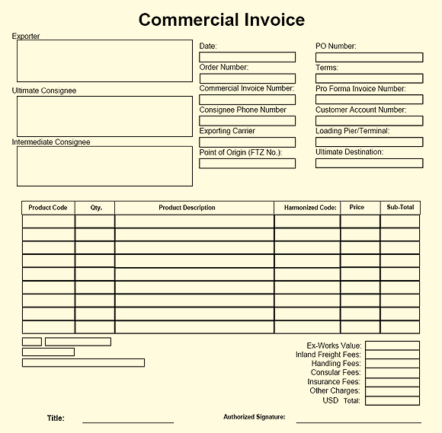

**LETTER OF CREDIT**

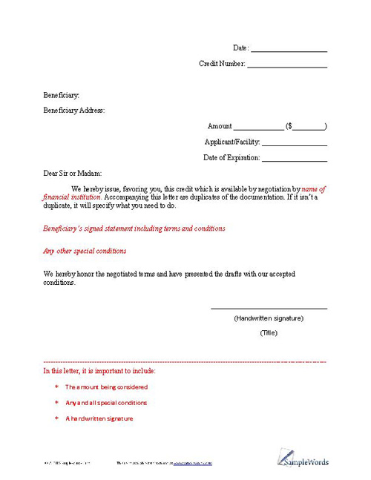

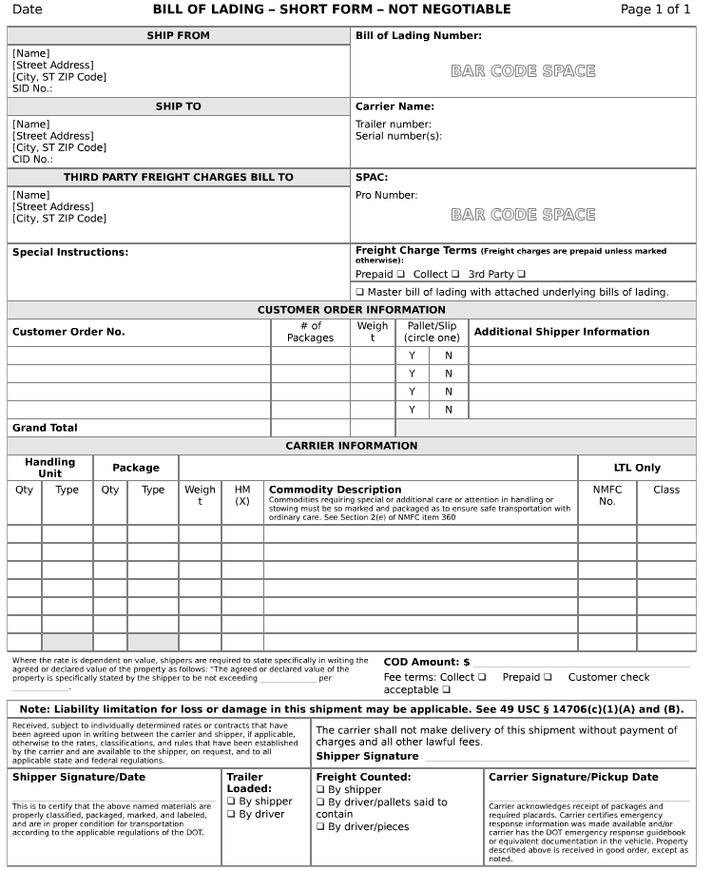

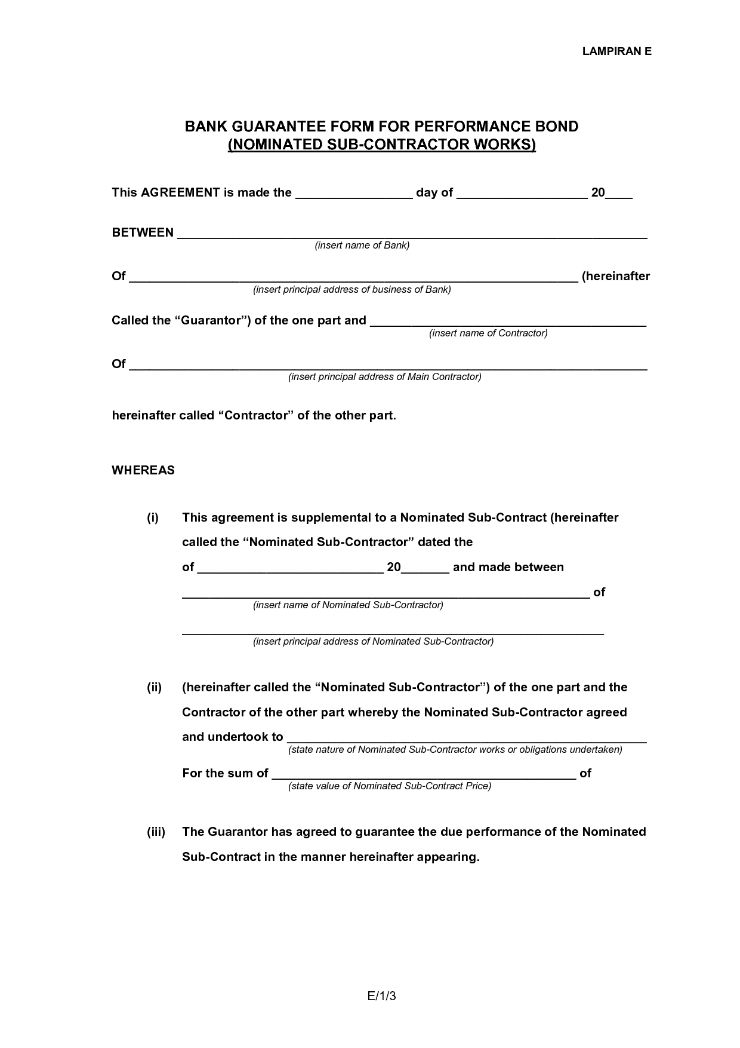

**BILL OF LADING**:

A document issued by a carrier (railroad, steamship or trucking company) which serves as a receipt for the goods to be delivered to a designated person or to his order. The bill of lading describes the conditions under which the goods are accepted by the carrier and details that nature and quantity of the goods, name of vessel (if shipped by sea), identifying marks and numbers, destination, etc. The person sending the goods is the “shipper” or “consignor”, the company or agent transporting the goods is the “carrier” and “and the person for whom the goods are destined is the “consignee”. Bills of lading may be negotiable or non-negotiable. If negotiable, i.e., payable to the shipper’s order and properly endorsed, title of the goods passes upon delivery of the bill of lading.

**LETTER OF CREDIT:**

It’s a media that protects both parties so that seller can get guarantee and if the buyer is not making advance payments. L/C is issued by the buyer’s bank after the deal has been finalized in favor of seller’s bank (name of the seller as specified). It’s a bank-to-bank transaction. L/C is a negotiable instrument i.e. the seller can get his payment from any bank and anywhere in his country. It may be revocable or irrevocable document. An irrevocable L/C provides guarantee by the issuing bank in the event that all terms and conditions are met by the buyer of the goods (or drawee). A revocable L/C can be cancelled or altered by the drawee after it has been issued by the drawee’s bank. A confirmed L/C is one issued by a bank which is validated or guaranteed by another bank.

**BANK GUARANTEE:**

A bank guarantee, like a line of credit, guarantees a sum of money to a beneficiary. Unlike a line of credit, the sum is only paid if the opposing party does not fulfill the stipulated obligations under the contract. This can be used to essentially insure a buyer or seller from loss or damage due to nonperformance by the other party in a contract. A bank guarantee might be used when a buyer obtains goods from a seller then runs into cash flow difficulties and can't pay the seller. The bank guarantee would pay an agreed-upon sum to the seller. Similarly, if the supplier was unable to provide the goods, the bank would then pay the purchaser the agreed-upon sum. Essentially, the bank guarantee acts as a safety measure for the opposing party in the transaction.

**CHAPTER IV**

**Conclusion and Recommendation**

**CONCLUSION**

The analysis of the firm’s financial statements consists of mixture of steps and pieces that interrelate and affect each other. No one part of the analysis should be interpreted in isolation. Short term liquidity impacts profitability; profitability begins with sales, which relate to the liquidity of assets. The efficiency of asset management influences the cost and availability of credit, which shapes the capital structure. Every aspect of a firm’s financial condition, performance, and outlook affects the share price. The last step of financial statement analysis is to integrate the separate pieces into a whole, leading to conclusions about the business enterprise. The specific conclusions drawn will be affected by the original objectives established at the initiation of the analytical process.

**RECOMMENDATIONS**

So there have some weaknesses that act as barriers for being better performance of JAT. If the company can reduced this kind of barriers, company can be successes. So they can take some action to recover those barriers that is:-

* Have to can increase sales
* Company must follow the chain of command
* To make effective salary structure
* Have to reduced short term loan
* Have to reduce new store expansion Because if it increase more in a year, the expenses of lease payment are increasing too.

The managerial performance of JAT is also very good but for more better in future they can take some action which is given below:

* Adaptation of more advance technology in their production process.
* Improvement of compensation structure for the staffs and employees.
* Uses of Modern updated software’s in all departments for accomplishing the task which I think will make the work more effective and efficient. It will also save a lot of time and energy.
* Evaluation for the good performance of the employees by introducing award and incentives.
* JAT should improve its existing distribution system.
* Delivery schedule should be modified, i.e., the number of weekly delivery should be increased according to the demand and expectations of the dealers.
* More surveys can be done in order to identify more deeply the causes of poor performance and other areas of flaws.
* Customers’ database should be maintained using software that is more sophisticated so that existing road map/plan can easily be modified anytime.
* Modern and versatile software should be used to run the process of keeping records and invoices so that anytime a recheck can be possible.
* Crosschecking of every records and activities should be introduced and practiced.
* Beside distribution, JAT should concentrate on improving the other areas of operation as well.
* Brand equity in terms of market share should be the main focal now because distribution
* alone can do nothing if the customers ultimately do not demand the product

**MY EXPERIENCE**

I had a wonderful experience in (JAT LTD.). From the time of submission of the application form till the time of the completion of the training, it was absolute fun and a learning experience as well.

I learnt the way how most of the objectives are accomplished at the Private Sector . I got to know how various tasks like, data entry, tender floating, trading, fund management, etc. are performed in a company.

**BIBLIOGRAPHY**

♦-Lyn M. Fraser –“Understanding financial statement” – (Ed-5th )

♦– Ross Westerfield Jordan -“Fundamentals of Corporate finance” – (Ed-5th)

♦ – Bodie * Kane * Marcus “Investment” – (Ed-5th )

♦– Richard Pike * Bill Neale “Corporate Finance & Investment” - (Ed-5th )

♦– Rose “Money and Capital Markets” –(Ed-6th )

♦JAT 13th Annual Report 2019-2020.

♦ Kothari, C R, Research Methodology Methods & Techniques, (2nd Ed.). New Delhi, H. S. Poplai for Wisha Prakashan

♦http://jpmgroup.co.in/

♦ Oral discussion with department managers.